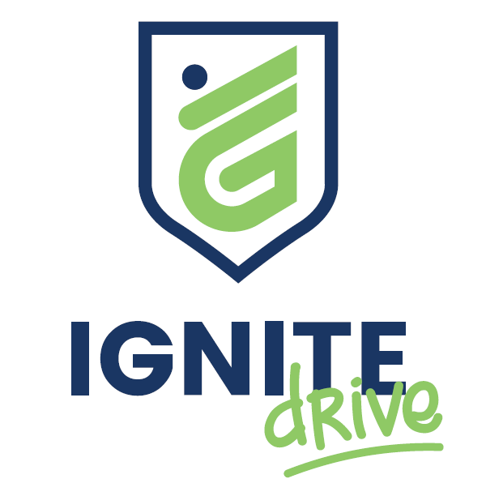
Commitment Form
Participation in the Ignite Drive programme comes with responsibilities to ensure the safety, wellbeing, and success of all involved. Failure to meet these expectations may result in removal from the programme.

Participant Commitments
By signing this form, you agree to the following:
Respect for Vehicle:
I will treat the vehicle with care and respect at all times.

Communication & Availability:
I will provide accurate contact details and clearly communicate lesson locations (including home address if required) to the Ignite Drive Manager to support lesson planning.

Raising Concerns:
I will communicate promptly with the Ignite Drive Manager regarding any issues with lesson times, scheduling, or any other concerns.

Legal Responsibilities:
I will declare any demerit points, fines, infringement notices, or police involvement immediately.

Punctuality & Behaviour:
I will attend all lessons on time and behave in a respectful, courteous, and attentive manner during all sessions.

Zero Tolerance for Illegal or Abusive Behaviour:
I understand that any illegal activity, or verbal or physical abuse, will result in immediate removal from the programme and may be reported.

Drug & Alcohol-Free Commitment:
I will not consume or be under the influence of drugs or alcohol on any day I am participating in lessons, training, or driving tests.

Attendance Expectations:
I understand that missing more than two lessons without communication will result in removal from the programme.

Disclaimer & Acknowledgement
Voluntary Participation:
I acknowledge that my participation in the Ignite Drive programme is voluntary and may be withdrawn at any time by either party.

Assumption of Risk:
I understand that driver training and related activities carry inherent risks. I agree to follow all instructions, comply with all applicable road rules, and take reasonable care for my own safety and the safety of others at all times.

Fitness to Participate:
I confirm that I am medically, physically, and legally fit to undertake driving activities. I agree to immediately notify Ignite Drive of any condition, injury, medication, or circumstance that may affect my ability to drive safely or legally.

Licence & Legal Status:
I confirm that I hold the appropriate current driver licence (or permit) required for participation and will comply with all licence conditions and legal requirements under New Zealand law.

Liability:
To the extent permitted by New Zealand law, I acknowledge that Ignite Drive, its employees, contractors, and volunteers are not liable for any loss, damage, or injury arising from my participation, except where such loss or damage is caused by their negligence or breach of statutory duty.

Vehicle Use & Insurance:
I understand that programme vehicles are insured; however, I may be held liable for any insurance excess or costs arising from damage caused by my negligent, reckless, or unlawful actions.

Conduct:
I acknowledge that any illegal behaviour, or verbal or physical abuse, may result in immediate removal from the programme and may be referred to appropriate authorities.

Privacy:
I consent to the collection, use, and storage of my personal information for the purposes of programme delivery, safety, and reporting, in accordance with the Privacy Act 2020 (NZ). I understand I have the right to access and request correction of my personal information.

Participant Details
Full Name:

Phone Number:

Address:

Participant Signature: Date:

Parent / Guardian Consent (if under 18)
I consent to the participant taking part and acknowledge the risks. I confirm they are fit to participate and will support programme requirements.
Name:

Signature:

Relationship:

Contact Number: Date:

